Boosting Algorithm:

Boosting algorithm is ensemble techinique improves the accuracy of the model by combining multiple weak learners to create a strong learners.

Step 1:

Analyse an draw decision separating the + and -

Step 2:

False prediction will move to next step and again checking.

Step 3:

Repeat the step 2 untill right prediction

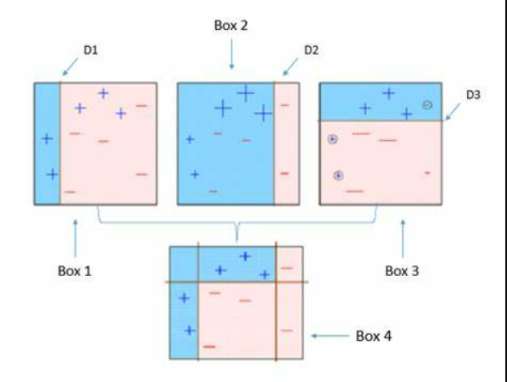

Ada Boost Algorithm:

Ada Boost Algorithm is improves the performance of week classifiers by focusing on the instance that are hard to classify.

Step 1:

Same work as normal boosting algorithm

Step 2:

Transforming weak learners into strong learners

Step 3:

By giving increment weight concepts

Step 4:

Used for both classification and regression prblems

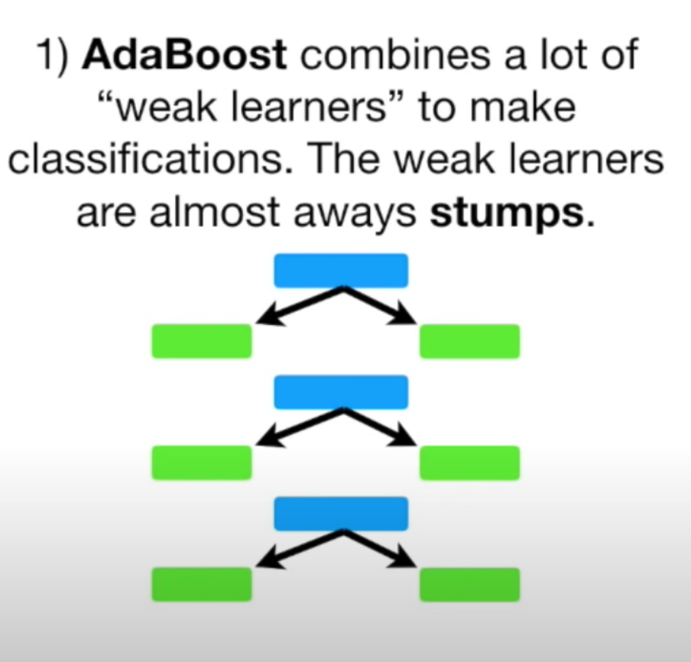

XG Boost Algorithm:

1. Same as gradient boosting but has different functionality
2. Disturbed machine learning process
3. More computational speed and efficiency

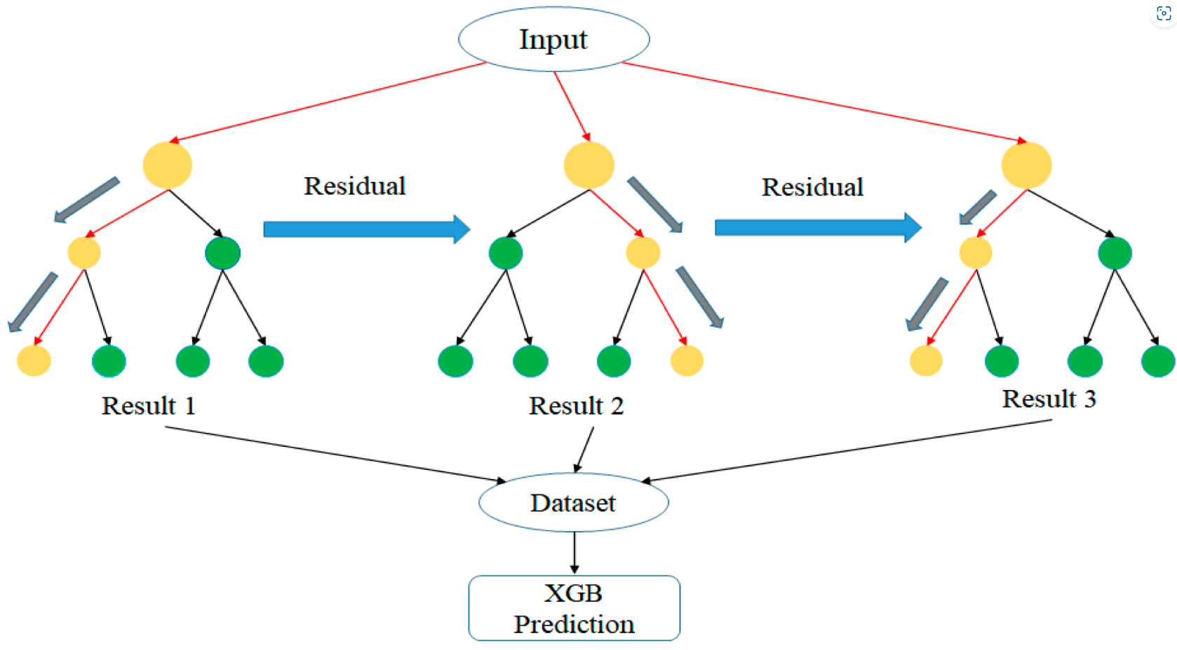

LG Boosting Algorithm:

1. Huge amount of data easy handle
2. Poor in smaller dataset
3. It uses histogram based method for selecting best fit method
4. For continuous values

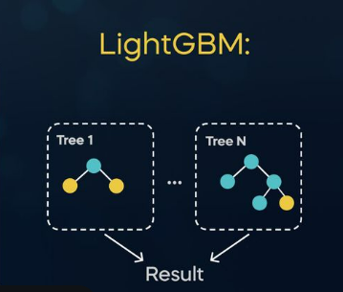

XG BOOST ALGORITHM

|  |  |  |
| --- | --- | --- |
| objective | n_estimators | R2_score |
| reg:squarederror | 100 | 0.81945 |
| reg:squarederror | 50 | 0.83245 |
|  |  |  |

Ada Boost Algorithm

R2_score= 0.828112

LG Boosting Algorithm

**R2_score= 0.859289**

I am choosing LG Boosting Algorithm it producing the high accuracy of the model.